Queries:

# Newsletter?

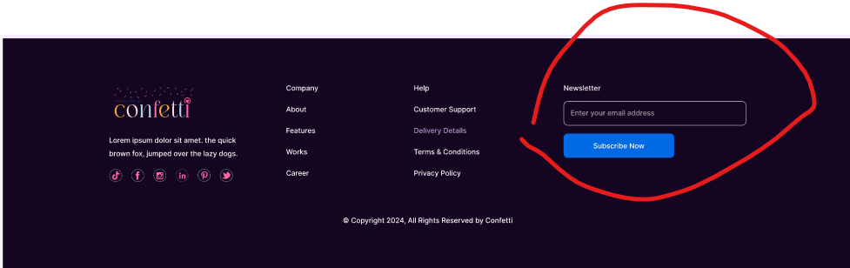

# Single case study?

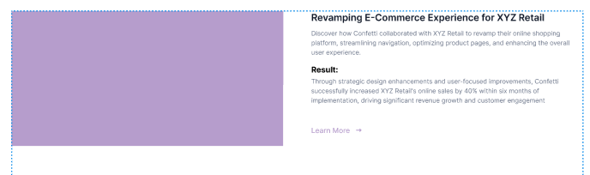

How this will be displayed and added

# Ideas and inspiration and User community?

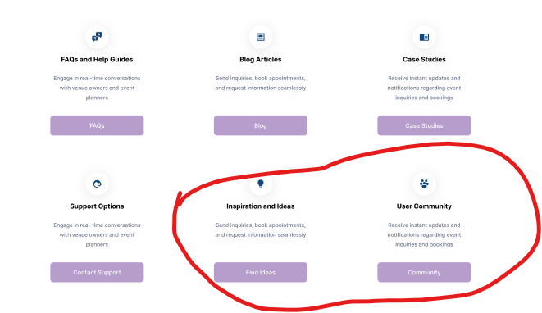

How to register as venue owner or customer

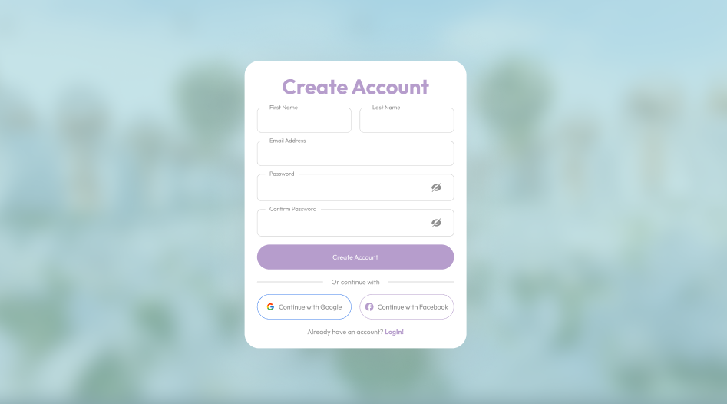

Also need page to add venues and venue attributes

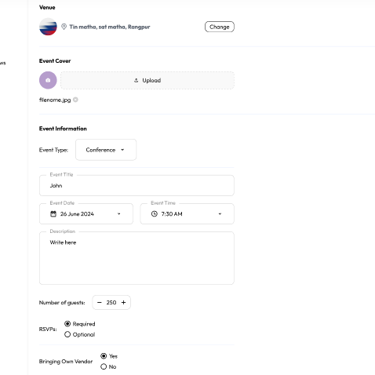

Event duration?